Module Name: Financial and Business Analytics

Professor: Suman Gurbani

Student Name: Victory Njoku (20087432), Muzzamil Aftab (20094751), Dhanush Muthyala (20096058), Mohammed Parvez (20096108)

Assignment Title

Comparing Different Companies’ Performances

- Executive Summary

The purpose of this report is to conduct the financial performance and investment feasibility assessment of Tesco plc and Loblaw Companies Ltd for the time period between 2023 and 2025. And then give investment recommendation and justification of our recommendation to the Executive Board of Directors of Wood's plc. Financial performance analysis and investment assessment were done by using annual reports of the companies, backed up with ratio analysis, market performance and other sources of external business information. First we did manual calculations of financial ratios then did AI analysis and compared our manual calculation and its ratios with those generated by AI.
As can be seen from the findings, both Tesco plc and Loblaw Companies Ltd are financially stable and high performers throughout the three years. However, Loblaw managed to maintain a consistently high level of profit margins and solid performance results and Tesco demonstrated a higher growth in all important metrics such as profitability, operational effectiveness, returns on capital and increase in shareholder value. Market analysis has revealed investor confidence, expressed through the increase in share price, growing market share and positive news about business.
Both companies are good and profitable investments, but Tesco is quite good in terms of growth potential and improvements in key performance areas. After considering all findings and analysis results, Tesco plc is recommended as an object of investment for Wood's plc.

- Introduction

2.1 Purpose of the Report

This report aims to perform and provide a detailed analysis of Tesco plc and Loblaw Companies Ltd. by undertaking several quantitative analyses on both companies, critically analyzing their backgrounds and presenting a well detailed and clear report for the use of the Executive Board of Directors of Wood’s plc.

2.2. Companies of Interest

In this report, we will be exploring Tesco plc and Loblaw Companies ltd. in a comparative manner using manual calculations as well as AI-Generated calculation (Claude AI) with enough evidence in addition to our final recommendation, to support the decision-making process for the Executive Board of Directors of Wood’s Plc to make a final decision on the company to invest in.

2.3 Industry Overview

These are both similar companies that operate in the grocery retail industry, while they do operate in different countries, they are considered to be supermarket and grocery retail giants in their respective countries. Sharma et al. (2022) describes Tesco plc as the biggest retailer in the UK and the third biggest retailer in the world, with locations in Europe, the United States, and Asia, while Babin and Li (2022) describes Loblaw as the largest food retailer in Canada.

- Company Overview

3.1. Tesco Plc:

Tesco Plc is one of the biggest food retailers and largest supermarket chain in the UK. Tesco was established back in 1919 by Jack Cohen. It is currently headquartered in Welwyn Garden City, Hertfordshire, England. Tesco has supermarket chains, convenience stores, and online shops operating in the United Kingdom, Ireland, and Central Europe. Besides food retail, Tesco also provides customers with clothing, home products, mobile services, and financial services via Tesco Bank. Tesco is currently serving millions of customers on a weekly basis. The company strives to provide its customers with high-quality products at competitive prices. Tesco Plc. (2025)

3.2. Loblaw Companies Limited

Loblaw Companies Limited is the largest retailer of food and pharmacy products in Canada and one of the biggest suppliers of grocery, health, and consumer goods. This company was founded in 1919, and its headquarters is located in Brampton, Ontario, Canada. Loblaw has a vast network of supermarkets, pharmacies, and retail stores under several popular brands, including Loblaws, Real Canadian Superstore, No Frills, Shoppers Drug Mart, and Joe Fresh. Besides being engaged in the sale of food items, this company also offers pharmacy services, health care products, fashion clothing, and financial services via PC Financial. Loblaw Companies Limited. (2025).

Ratio Analysis: Manual Calculations

4.1 Indication of Key Measures

Key Measures | Company | 2023 | 2024 | 2025
Gross Profit | Tesco plc (£m) | 3,661 | 4,849 | 5051
 | Loblaw Ltd. ($ Cad) | 18,083 | 18,835 | 20,032
Sales | Tesco plc (£m) | 65,762 | 68,187 | 69916
 | Loblaw Ltd. ($ Cad) | 58,345 | 60123 | 63903
Net Profit Before Tax | Tesco plc (£m) | 1000 | 2289 | 2215
 | Loblaw Ltd. ($m Cad) | 2901 | 2791 | 3682
Total Assets | Tesco plc (£m) | 46,132 | 47039 | 38890
 | Loblaw Ltd. ($m Cad) | 41,577 | 40,880 | 38,979
Current Assets | Tesco plc (£m) | 12,725 | 16,606 | 8856
 | Loblaw Ltd. | 13,578 | 14548 | 14928
Current Liabilities | Tesco plc (£m) | 5010 | 3866 | 4,964
 | Loblaw Ltd. | 10,847 | 11,768 | 13870
Inventory | Tesco plc (£m) | 2510 | 2635 | 2768
 | Loblaw Ltd. ($m Cad) | 5820 | 6330 | 6491
Long-Term Debt | Tesco plc (£m) | 5581 | 5683 | 5089
 | Loblaw Ltd. ($m) | 6,661 | 7570 | 5891
Equity | Tesco plc (£m) | 12230 | 11665 | 11,662
 | Loblaw Ltd. ($m cad) | 11,619 | 11,266 | 11,192
Profit Before Interest and Tax | Tesco plc | 1525 | 2821 | 2711
 | Loblaw Ltd. | 3704 | 3474 | 4424
Interest Payable | Tesco plc (£m) | 618 | 805 | 746
 | Loblaw Ltd. | 803 | 683 | 742
Profit After Tax | Tesco plc (£m) | 744 | 1192 | 1630
 | Loblaw Ltd. ($ Cad) | 2187 | 2275 | 2738
Dividend Paid and Payable | Tesco plc (£m) | 859 | 778 | 864
 | Loblaw Ltd. ($m Cad) | 562 | 459 | 812
Cost of Goods Sold | Tesco plc (£m) | 62,034 | 62,836 | 64,205
 | Loblaw Ltd. ($m Cad) | 40,492 | 41,288 | 43,871
Inventory Turnover | Tesco plc (Days) | 25.6 | 24.4 | 23.8
 | Loblaw Ltd. (Days) | 6.9 | 6.8 | 6.8
Account Receivables | Tesco plc | 1315 | 1349 | 1210
 | Loblaw Ltd. ($m Cad) | 1,298 | 1455 | 1290
Account Payable | Tesco plc (£m) | 9818 | 10,264 | 10,364
 | Loblaw Ltd. ($m Cad) | 6324 | 7531 | 7127
Number of Shares in Issue | Tesco plc | 7,318,341,195 | 7,038,930,440 | 6,736,841,762
 | Loblaw Ltd. | 310,526,379 | 301,736,053 | 1,175,146,201
Total Dividend | Tesco plc (£m) | 858 | 777 | 865
 | Loblaw Ltd. ($ Cad) | 562 | 616 | 654
Dividend Per Share | Tesco plc | 10.90p | 12.10p | 13.70p
 | Loblaw Ltd. ($) | 0.436 | 0.496 | 0.551
Share Price | Tesco plc | 202.35 | 290.5 | 349.1
 | Loblaw Ltd. ($ Cad) | 120.31 | 153.42 | 52.66
Retained Earnings | Tesco plc (£m) | 3490 | 2930 | 2935
 | Loblaw Ltd. ($m) | 4,816 | 4748 | 4804
Capital Employed | Tesco plc | 7220 | 7799 | 6698
 | Loblaw Ltd. | 30,730 | 29,112 | 25,109
Share Capital | Tesco plc | 463 | 445 | 426
 | Loblaw Ltd. | 6477 | 6196 | 6075

4.2 Calculation of Ratios

Ratios | Key Measures | Company | 2023 | 2024 | 2025
Profitability Ratios
 | Gross Profit Margin (Gross profit/ Sales) | Tesco plc | 5.57% | 7.11% | 7.22%
 |  | Loblaw Ltd. | 30.99% | 31.33% | 31.35%
 | Net Profit Margin (Net Profit Before Tax / Sales) | Tesco plc | 1.52% | 3.36% | 3.17%
 |  | Loblaw Ltd. | 4.97% | 4.64% | 5.76%
 | Sales-To-assets (Sales /Total Assets) | Tesco plc | 1.4 | 1.4 | 1.80
 |  | Loblaw Ltd. | 1.4 | 1.5 | 1.6
 | Return on Assets (Net Profit Before Tax /Total Assets) | Tesco plc | 2.17% | 4.87% | 5.70%
 |  | Loblaw Ltd. | 6.98% | 6.83% | 9.45%
Liquidity and Solvency Ratios
 | Current Ratio (Current Assets / Current Liabilities) | Tesco plc | 2.54 | 4.30 | 1.78
 |  | Loblaw Ltd. | 1.25 | 1.24 | 1.08
 | Quick Ratio (Current Assets - Inventory / Current Liabilities) | Tesco plc | 2.04 | 3.61 | 1.23
 |  | Loblaw Ltd. | 0.72 | 0.70 | 0.61
 | Gearing Ratio (Long-Term Debt / LT Debt + Equity) | Tesco plc | 31.33% | 32.76% | 30.38%
 |  | Loblaw Ltd. | 36.44% | 40.19% | 34.48%
 | Interest Cover (Profit Before Interest and Tax / Interest Payable) | Tesco plc | 2.5 | 3.5 | 3.6
 |  | Loblaw Ltd. | 4.6 | 5.1 | 6.0
 | Dividend Cover (Profit After Tax/ Dividend Paid and Payable) | Tesco plc | 0.9 | 1.5 | 1.9
 |  | Loblaw Ltd. | 3.9 | 5.0 | 3.4
Efficiency Ratios
 | Inventory Days (365/ Inventory Turnover) | Tesco plc | 14.8 | 15.3 | 15.7
 |  | Loblaw Ltd. | 52.5 | 56.0 | 54.0
 | Account Receivable Days (Account Receivable x 365 / Cost of Sales) | Tesco plc | 7.7 | 7.8 | 6.9
 |  | Loblaw Ltd. | 11.7 | 12.9 | 10.7
 | Account Payable Days (Account Payable x 365 / Cost of Sales) | Tesco plc | 57.8 | 59.6 | 58.9
 |  | Loblaw Ltd. | 57.0 | 66.6 | 59.3
 | Inventory Turnover (Cost of Goods Sold / Inventory) | Tesco plc | 24.7 | 23.8 | 23.2
 |  | Loblaw Ltd. | 7.0 | 6.5 | 6.8
Investment Ratios
 | Earnings Per Share (from the Financial Statement) (Pence) | Tesco plc | $10.05 | $16.74 | $23.79
 |  | Loblaw Ltd. | $6.59 | $7.06 | $2.24
 | Dividend Per Share | Tesco plc | 10.90p | 12.10p | 13.70p
 |  | Loblaw Ltd. ($) | 0.436 | 0.496 | 0.551
 | Dividend Yield (Dividend Per Share/ Share Price) | Tesco plc | £0.054 | £0.042 | £0.039
 |  | Loblaw Ltd. | $0.0036 | $0.0032 | $0.010
 | Price/ Earnings Ratio (Share Price / Earnings per Share) (£) | Tesco plc | 1990411748.40 | 1715444037.60 | 1442841385.96
 |  | Loblaw Ltd. | $17,082,500.53 | $20,348,283.63 | $22,601,606.63
 | Return on Equity (Profit before tax / Share capital + Retained Earnings) | Tesco plc | 25.30% | 67.82% | 65.90%
 |  | Loblaw Ltd. | 25.69% | 25.50% | 33.85%
 | Return on Capital Employed (Profit Before Interest and Tax/ Capital Employed) | Tesco plc | 21.12% | 36.17% | 40.47%
 |  | Loblaw Ltd. | 12.05% | 11.93% | 17.62%

4.3. Analysis of Ratios

Tesco profitability generally increased consecutively from 2023 to 2025; this is evident from the gross profit margin that went from 5.57% in 2023 to 7.11% in 2024 and then 7.22% in 2025. Additionally, sales-to-assets and return on assets also demonstrated similar increases. Tesco’s net profit margin, however, increased from 2023 to 2024 but experienced a slight decline in 2025. This decline could have occurred as a result of an increase in the company’s expenses.

Moreover, Tesco’s liquidity and solvency ratios, which measure its ability to pay its bills on time mostly showed increases from 2023 to 2024 but in 2025, ratios like the current and quick ratio declined. A decline in current ratio means that in 2025 Tesco witnessed an increase in current liabilities in comparison with its current assets, this could affect its ability to pay its short-term debt as well as its accounts payable. The drop in the quick ratio in 2025 indicates that as at 2025 Tesco was not bringing in sufficient resources to pay its bills on time.

In order to assess how efficiently Tesco uses its resources and assets, we have calculated efficiency ratios. Tesco has had a steady decline in inventory turnover, this means Tesco’s efficiency in inventory management has been on a decline for the past three years and this clearly implies that each year the company is finding it more difficult to sell its product. Based on the calculation of inventory days, Tesco averagely held its product in inventory 14.8 days in 2023, 15.3 days in 2024 and 15.7 days in 2025. Furthermore, in 2025 the company showed relentlessness in collecting the money that is owed to them, this is evident in the account receivable days reducing to 6.9 days in 2025 from 7.8 days in 2024 and 7.7 days in 2023. Similarly, this can be said for the money the company was owing its creditors. There was an increase from 57.8 days in 2023 to 59.6 days in 2024 and then a reduction in 2025 to 58.9 days.

In order to properly understand the status of Tesco’s investments, we extracted Tesco’s earnings per share from its annual report and we discovered an increase from 2023 - 2025 consecutively, indicating that for the past three years, the company has been making a higher amount of profit for each share. Moreover, other calculations were done to assess Tesco’s investments. An increase in dividend per share from 2023 through 2025 indicates a promising future as this means that for each share held, shareholders could be expecting to receive 10.90p in 2023, 12.10p in 2024 and 13.70p in 2025. However, the decline in dividend yield from 2023 to 2025 questions the attractiveness of Tesco’s investments. Furthermore, from 2023 to 2025, Tesco experienced an increase of Return on Capital Employed (ROCE) indicating a steady increase in the returns generated by the total resources invested in the company.

Loblaw on the other hand, has witnessed a steady increase in its gross profit margin from 2023 to 2025, the same can be said for its sales-to-assets ratio but there was a drop from 2023 to 2024. While these are good signs for the company and its profitability ratio, it is also important to to highlight the decline in the net profit margin from 2023 to 2024 possibly due to an increase in expenses, however this was reversed the following year as Loblaw experienced a 5.76% net profit margin in 2025 compared to the 4.64% the previous year.

The year 2025 has proven to be a difficult year for Loblaw in its ability to pay its bills on time. Ratios such as Current ratio, quick ratio and dividend cover prove this. Loblaw had a current ratio of 1.25 in 2023, 1.24 in 2024 and 1.08 in 2025, indicating its declining ability to easily convert its assets to cash to pay its bills. Its declining quick ratio indicates that from 2023 to 2025 Loblaw was not bringing in sufficient resources to pay its bills on time. Its gearing ratio was 36.44% in 2023 but increased in 2024 to 40.19% which is risky for Loblaw because it highlights that the company was geared on long-term debt as a source of finance other than share capital or equity. However, in 2025, there was a reduction in the gearing ratio to 34.48% which is positive for the company as it is moving away from relying on debt for its financing.

In 2023, Loblaw turned over its inventory averagely 7 times in a year, in 2024, this decreased to 6.5 times in a year and in 2025, this decreased to average 6.8 times in a year. This indicates that Tesco has been able to turn over their products more times than lob laws from 2023 to 2025. As proven with the account receivable days, Tesco has shown more ability to collect the money being owed by debtors sooner than Loblaw. Loblaw has an average of 10.7 days of account receivable in 2025, this was a decrease of 2024 and 2023 but this is also more than Tesco's accounts receivable days in 2023 through 2025, indicating how well Tesco is performing in efficiency ratio compared to Loblaw. However, Loblaw outperformed Tesco in 2023 in accounts payable days, indicating that Loblaw was able to pay its debt at a faster time period compared to Tesco. Moreover, in 2024 and 2025, Loblaw had 66.6 days and 59.3 days respectively. These were higher days compared to Tesco’s account payable days for these years, highlighting that in 2024 and 2025 Tesco took less time to pay its bills compared to Loblaw.

With respect to its investment ratios, using the annual report of Loblaw for its earnings per share, we were able to confirm that in 2023 and 2024 the company was making a higher amount of profit for each share in these years but a much low earning per share in 2025, moreover Loblaw outperformed Tesco from 2023-2025 in earnings per share. Similar to Tesco, an increase in dividend per share from 2023 through 2025 indicates a promising future for Loblaws as this means that for each share held, shareholders could be expecting to receive C$0.436 in 2023, C$0.496 in 2024 and C$0.551 in 2025. However, the decline in dividend yield from 2023 to 2025 also means that the attractiveness of Loblaw’s investments has been on a decline. Furthermore, from 2023 to 2025, Tesco experienced an increase of ROCE but Loblaw only witnessed an increase in ROCE from 2024 to 2025 indicating an increase in the returns generated by the total resources invested in the company but this also means that there was a decrease in the returns generated by the total resources invested in the company from 2023 to 2024.

- Claude AI-Generated Analysis

5.1 Comparison of Formula

Gross Profit Margin

Manual Calculation
Claude AI (Tesco plc)
Claude AI (Loblaw)

Net Profit Margin

Manual Calculation

Claude AI (Tesco plc)
Claude AI (Loblaw)

Sales-To-Assets
Manual Calculation

Claude AI (Tesco plc)

Claude AI (Loblaw)

Return on Assets

Manual Calculation

Claude AI (Tesco plc)
Claude (Loblaw)

Current Ratio

Manual Calculation
Claude AI (Tesco plc)
Claude AI (Loblaw)

Quick Ratio

Manual Calculation

Claude AI (Tesco plc)
Claude AI (Loblaw)

Gearing Ratio

Manual Calculations
Claude AI (Tesco plc)
Claude AI (Loblaw)

Interest Cover

Manual Calculations
Claude AI (Tesco plc)
Claude (Loblaw)

Dividend Cover

Manual Calculations
Claude AI (Tesco plc)
Claude AI(Loblaw)

Inventory Days

Manual Calculations
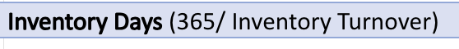
Claude AI (Tesco plc)
Claude AI (Loblaw)

Account Receivable Days

Manual Calculations
Claude AI (Tesco plc)
Claude AI (Loblaw)

Account Payable Days

Manual Calculations
Claude AI (Tesco plc)
Claude AI (Loblaw)

Inventory Turnover

Manual Calculations
Claude AI (Tesco plc)
Claude AI (Loblaw)

Earnings Per Share

Manual Calculations
Claude AI (Tesco)
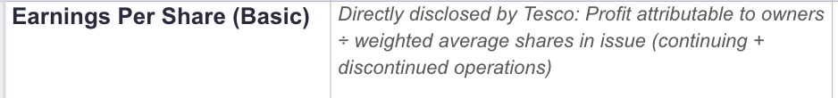
Claude AI (Loblaw)


Dividend Per Share

Manual Calculations
No formula, listed on financial statement

Claude AI (Tesco plc)
Claude AI (Loblaw)

Dividend Yield

Manual Calculations
Claude AI (Tesco plc)
Claude AI (Loblaw)

Price/ Earnings Ratio

Manual Calculations
Claude AI (Tesco plc)
Claude (Loblaw)

Return on Equity

Manual Calculations
Claude AI (Tesco plc)

Claude AI (Loblaw)

Return on Capital Employed (ROCE)

Manual Calculations
Claude AI (Tesco plc)

Claude AI (Loblaw)

5.2. Comparison of Calculations

🔴- Indicates differences between Manual calculations and Claude AI calculations
🟢- Indicates the same calculation between Manual calculations and Claude AI calculations

Tesco plc

Ratio | Year | Manual Calculations | Claude AI Calculations
Gross Profit Margin | 2023 | 5.57% 🟢 | 5.57%🟢
Gross Profit Margin | 2024 | 7.11%🟢 | 7.11%🟢
Gross Profit Margin | 2025 | 7.22%🟢 | 7.22%🟢
Net Profit Margin | 2023 | 1.52% 🔴 | 1.13%🔴
Net Profit Margin | 2024 | 3.36%🔴 | 1.74%🔴
Net Profit Margin | 2025 | 3.17%🔴 | 2.33% 🔴
Sales-to-Assets | 2023 | 1.43x🟢 | 1.43x🟢
Sales-to-Assets | 2024 | 1.45x 🟢 | 1.45x🟢
Sales-to-Assets | 2025 | 1.80x 🟢 | 1.80x🟢
Return on Assets | 2023 | 2.17% 🔴 | 1.61%🔴
Return on Assets | 2024 | 4.87% 🔴 | 2.53%🔴
Return on Assets | 2025 | 5.70% 🔴 | 4.18%🔴
Current Ratio | 2023 | 0.72🟢 | 0.72🟢
Current Ratio | 2024 | 1.24 🔴 | 0.81🔴
Current Ratio | 2025 | 0.64🟢 | 0.64🟢
Quick Ratio | 2023 | 0.58🟢 | 0.58🟢
Quick Ratio | 2024 | 1.05 🔴 | 0.61🔴
Quick Ratio | 2025 | 0.44🟢 | 0.44🟢
Gearing Ratio | 2023 | 31.33%🔴 | 123.3%🔴
Gearing Ratio | 2024 | 32.76%🔴 | 127.2%🔴
Gearing Ratio | 2025 | 30.38%🔴 | 125.8%🔴
Interest Cover | 2023 | 2.5 🟢 | 2.47🟢
Interest Cover | 2024 | 3.5 🟢 | 3.50 🟢
Interest Cover | 2025 | 3.6 🟢 | 3.63 🟢
Dividend Cover | 2023 | 0.9🟢 | 0.92🟢
Dividend Cover | 2024 | 1.5 🔴 | 1.38 🔴
Dividend Cover | 2025 | 1.9 🔴 | 1.74 🔴
Inventory Days | 2023 | 14.8 🔴 | 14.27🔴
Inventory Days | 2024 | 15.3🔴 | 14.94🔴
Inventory Days | 2025 | 15.7🔴 | 15.36
Account Receivable Days | 2023 | 7.7🔴 | 7.15🔴
Account Receivable Days | 2024 | 7.8🔴 | 7.13🔴
Account Receivable Days | 2025 | 6.9🔴 | 6.68🔴
Account Payable Days | 2023 | 57.8🔴 | 55.89🔴
Account Payable Days | 2024 | 59.6🔴 | 58.33🔴
Account Payable Days | 2025 | 58.9🔴 | 58.63🔴
Inventory Turnover | 2023 | 24.7x🔴 | 25.59x🔴
Inventory Turnover | 2024 | 23.8x🔴 | 24.43x🔴
Inventory Turnover | 2025 | 23.2x🔴 | 23.77x🔴
Earnings Per Share | 2023 | 10.05p🟢 | 10.05p🟢
Earnings Per Share | 2024 | 16.74p🟢 | 16.74p🟢
Earnings Per Share | 2025 | 23.79p🟢 | 23.79p🟢
Dividend Per Share | 2023 | 10.90p🟢 | 10.90p🟢
Dividend Per Share | 2024 | 12.10p🟢 | 12.10p🟢
Dividend Per Share | 2025 | 13.70p🟢 | 13.70p🟢
Dividend Yield | 2023 | 0.054🔴 | 4.36%🔴
Dividend Yield | 2024 | 0.042🟢 | 4.25%🟢
Dividend Yield | 2025 | 0.039🔴 | 3.70%🔴
Price/Earning Ratio | 2023 | 1990411748.40🔴 | 24.88x🔴
Price/Earning Ratio | 2024 | 1715444037.60🔴 | 17.03x🔴
Price/Earning Ratio | 2025 | 1442841385.96🔴 | 15.55x🔴
Return on Equity | 2023 | 25.30%🔴 | 6.09%🔴
Return on Equity | 2024 | 67.82%🔴 | 10.18%🔴
Return on Equity | 2025 | 65.90%🔴 | 13.94%
Return on Capital Employed | 2023 | 21.12%🔴 | 5.37%🔴
Return on Capital Employed | 2024 | 36.17%🔴 | 10.62%🔴
Return on Capital Employed | 2025 | 40.47%🔴 | 10.81%🔴

Loblaws Ltd

Ratio | Year | Manual Calculations | Claude AI Calculations
Gross Profit Margin | 2023 | 30.99%🔴 | 31.98%🔴
Gross Profit Margin | 2024 | 31.33%🔴 | 32.33%🔴
Gross Profit Margin | 2025 | 31.35%🟢 | 31.35%🟢
Net Profit Margin | 2023 | 4.97%🔴 | 3.67%🔴
Net Profit Margin | 2024 | 4.64%🔴 | 3.73%🔴
Net Profit Margin | 2025 | 5.76%🔴 | 4.28%🔴
Sales-to-Assets | 2023 | 1.40x🔴 | 1.54x🔴
Sales-to-Assets | 2024 | 1.47x🔴 | 1.53x🔴
Sales-to-Assets | 2025 | 1.64x🔴 | 1.55x🔴
Return on Assets | 2023 | 6.98%🔴 | 5.67%🔴
Return on Assets | 2024 | 6.83%🔴 | 5.70%🔴
Return on Assets | 2025 | 9.45%🔴 | 6.64%🔴
Current Ratio | 2023 | 1.25x🟢 | 1.25x🟢
Current Ratio | 2024 | 1.24x🟢 | 1.24x🟢
Current Ratio | 2025 | 1.08x🟢 | 1.08x🟢
Quick Ratio | 2023 | 0.72🔴 | 0.69x🔴
Quick Ratio | 2024 | 0.70🔴 | 0.67x🔴
Quick Ratio | 2025 | 0.61🔴 | 0.58x🔴
Gearing Ratio | 2023 | 36.44%🔴 | 74.9%🔴
Gearing Ratio | 2024 | 40.19%🔴 | 79.9%🔴
Gearing Ratio | 2025 | 34.48%🔴 | 52.6%🔴
Interest Cover | 2023 | 4.6x🟢 | 4.61x🟢
Interest Cover | 2024 | 5.1x🔴 | 4.75x🔴
Interest Cover | 2025 | 6.0x🟢 | 5.96x🟢
Dividend Cover | 2023 | 3.9x🔴 | 3.78x🔴
Dividend Cover | 2024 | 5.0x🔴 | 3.56x🔴
Dividend Cover | 2025 | 3.4x🔴 | 4.06x🔴
Inventory Days | 2023 | 52.5 days🔴 | 52.6 days🔴
Inventory Days | 2024 | 56.0 days🔴 | 53.7 days🔴
Inventory Days | 2025 | 54.0 days🔴 | 53.3 days🔴
Account Receivable Days | 2023 | 11.7 days 🔴 | 7.65 days🔴
Account Receivable Days | 2024 | 12.9 days🔴 | 8.23 days🔴
Account Receivable Days | 2025 | 10.7 days🔴 | 7.84 days🔴
Account Payable Days | 2023 | 57.0 days🔴 | 56.5 days🔴
Account Payable Days | 2024 | 66.6 days🔴 | 61.2 days🔴
Account Payable Days | 2025 | 59.3 days 🔴 | 61.0 days🔴
Inventory Turnover | 2023 | 7.0x🔴 | 6.94x🔴
Inventory Turnover | 2024 | 6.5x🔴 | 6.80x🔴
Inventory Turnover | 2025 | 6.8x🟢 | 6.84x🟢
Earnings Per Share | 2023 | $6.59🟢 | $6.59🟢
Earnings Per Share | 2024 | $7.06🟢 | $7.06🟢
Earnings Per Share | 2025 | $2.24🟢 | $2.24🟢
Dividend Per Share | 2023 | $0.436🔴 | $1.743🔴
Dividend Per Share | 2024 | $0.496🔴 | $1.985🔴
Dividend Per Share | 2025 | $0.551🔴 | $0.5515🔴
Dividend Yield | 2023 | $0.0036🔴 | 1.36%🔴
Dividend Yield | 2024 | $0.0032🔴 | 1.05%🔴
Dividend Yield | 2025 | $0.010🔴 | 0.89%🔴
Price/Earning Ratio | 2023 | 17,082,500.53🔴 | 19.4x🔴
Price/Earning Ratio | 2024 | 20,348,283.63🔴 | 26.8x🔴
Price/Earning Ratio | 2025 | 22,601,606.63🔴 | 27.7x🔴
Return on Equity | 2023 | 25.69%🔴 | 18.45%🔴
Return on Equity | 2024 | 25.50%🔴 | 19.25%🔴
Return on Equity | 2025 | 33.85%🔴 | 24.11%🔴
Return on Capital Employed | 2023 | 12.05%🔴 | 13.19%🔴
Return on Capital Employed | 2024 | 11.93%🔴 | 13.63%🔴
Return on Capital Employed | 2025 | 17.62%🔴 | 15.57%🔴

5.3. AI Explanation and Validation

Tesco plc

Ratio | Year | Claude AI Explanation/Movement | Our Validation at Platinum Consultant Plc
Gross Profit Margin | 2023 -2025 | Rose from 5.6% to 7.1% to 7.2%. The FY2023→FY2024 jump is partly a classification effect: FY2023 gross profit was struck after an IFRS-9 bad-debt charge on Tesco Bank loans; from FY2024 the disposed/discontinued Banking business no longer burdens gross profit, and insurance costs (a much smaller charge) sit within cost of sales instead. Underlying retail margin also improved as cost inflation eased and Tesco's 'Save to Invest' cost programme delivered savings. The FY2024→FY2025 move (+0.1pt) reflects a much more modest, genuinely operational improvement in retail gross margin. | Considering that we at Platinum Consultant Plc used revenue as sales, Claude AI and us used the same formula.We also have the same calculations  As Claude AI for this analysis for the Tesco calculations while the Claude AI’s Loblaws calculations differ from ours except the 2025 calculations. Therefore, Claude AI calculation is validated for the analysis on Tesco and not Loblaw.
Net Profit Margin | 2023-2025 | Improved steadily from 1.1% to 1.7% to 2.3%. FY2023 net margin was heavily depressed by a large net impairment charge on property/leases/goodwill (c.£1bn) taken through operating profit; with no equivalent one-off in FY2024/FY2025, margin recovered. FY2025 also benefits from lower net finance costs and a smaller drag from discontinued operations (only £26m loss vs £572m loss in FY2024, when the Banking disposal completed). | Claude AI used Net earnings / Revenue to calculate net profit margin for Loblaw while it used profit attributable to owners / revenue for its net profit margins for Tesco, however the formula for our manual calculation was net profit before tax/sales. Our calculations are different from Claude AI for all three years. Claude AI calculation is not validated for this analysis.
Sales-to-Assets | 2023-2025 | Rose from 1.43x to 1.45x to 1.80x. The FY2024→FY2025 jump is largely a balance-sheet, not a trading, effect: total assets fell by c.£8bn as the Tesco Bank disposal completed in FY2025 (loan book, Bank-related investments and cash removed), while revenue kept growing. So Tesco is generating more revenue per £ of assets mainly because the asset base is now smaller and more retail-focused, not only because trading intensified. | Claude AI used Revenue / Total assets to calculate sales-to-assets for Tesco while it used revenue/ average total assets for its sales-to-assets for Loblaw, however the formula for our manual calculation was net profit before tax/total assets. Our calculations and answers are different from Claude AI for all three years for Loblaw but not for Tesco. It is different for Loblaw because it used average total Assets while we used tOTAL assets in the formula. Claude AI calculation is not validated for this analysis for Loblaw but it is validated for tesco.
Return on Assets | 2023-2025 | Climbed from 1.6% to 2.5% to 4.2%. Driven by both a rising numerator (profit recovery, as above) and a falling denominator: total assets fell from £46.1bn to £38.9bn as the Banking loan book and other Bank assets were sold/reclassified and removed from the balance sheet during FY2024–FY2025. The improvement therefore overstates the improvement in pure trading profitability — a meaningful part is a smaller, asset-lighter balance sheet post-disposal. | For Return on Assets, the formula used by Claude AI for its Tesco calculations is Profit attributable to owners / Total Assets while the formula it used for its Loblaw calculation is Net Earnings / Average Total Assets. The formula we used at Platinum Consultant Plc is Net Profit Before Tax / Total Assets and our calculations from 2023 - 2025 differ from Claude AI’s calculations. This is because we used net profit before tax in the calculation while Claude AI used Profit attributable to owners for its Tesco’s calculation and net earnings for its Loblaw calculation. We have therefore concluded that Claude AI calculation is not validated for the Return on Assets for both companies.
Current Ratio | 2023-2025 | Rose from 0.72 to 0.81 (FY2024, boosted by the Banking disposal group being classified as held-for-sale on both sides of the balance sheet), then fell back to 0.64 in FY2025 once the disposal completed and those held-for-sale balances dropped out entirely. Throughout, the ratio sits below 1.0 — normal for a grocery retailer, which collects cash from customers before it has to pay suppliers. | For its Tesco’s Current Ratio calculations, Claude AI used Total current assets including held-for-sale / Total Current Liabilities including held-for-sale. For its Loblaw’s Current Ratio calculation, it used current Assets / Current Liabilities. Our manual calculation also used Current Assets / Current Liabilities. Tesco’s current ratio calculations are similar with our manual calculation for both 2023 and 2025, however they differ in 2024, our calculation happens to be less than Claude’s calculation. The Loblaw’s calculations were all consistent with ours. For current ratio, our conclusion is that Claude AI is not validated for Tesco but it is validated for Loblaw.
Quick Ratio | 2023-2025 | Followed the same pattern as the current ratio: 0.58 → 0.68 → 0.44. The FY2025 fall looks the sharpest of any liquidity measure — mainly because the large held-for-sale Banking assets/liabilities that supported the FY2024 ratio are gone, leaving a leaner, more 'normal' supermarket balance sheet where current liabilities (mostly trade payables) comfortably exceed liquid current assets. This is a structural feature of the grocery model rather than a sign of distress, given Tesco's strong operating cash generation. | The formula used for Tesco’s Quick ratio by Claude AI is (Total Current Assets - Inventories) / Total Current Liabilities while the formula used for Loblaw’s Quick ratio is (Current Assets - Inventory - Prepaids) / Current Liabilities. The difference in these Claude’s formulas is that it deducted prepaid in its quick ratio. The formula we used is similar to the formula Claude AI used for its Tesco’s calculation, the we used is (Current Assets - Inventory) / Current Liabilities. Moreover, Tesco’s Quick ratio calculations are similar with our manual calculation for both 2023 and 2025, however they differ in 2024. Loblaw's calculations differ from ours for all the three years and this is because the formula included prepaid. We have concluded that Claude AI calculation is not validated for Quick Ratio for both companies.
Gearing Ratio | 2023-2025 | Broadly stable and high throughout: 123% → 127% → 126%. Total debt (borrowings + lease liabilities) has actually fallen slightly in absolute terms (£15.1bn → £14.8bn → £14.7bn) as Tesco has paid down borrowings, but a shrinking equity base (driven by ongoing share buybacks rather than losses) has kept the ratio elevated. Lease liabilities (mostly store leases) are the largest single component of 'debt' here — a normal feature of a store-based retailer, not a sign of financial distress; Tesco's own 'net debt' (which nets off cash) has fallen every year per its five-year record. | Claude AI used Interest-Bearing Debt / Total Equity to calculate Gearing Ratio for Loblaw while it used (Total borrowings + Total Lease Liabilities, Current + Non-Current) / Total Equity for its Gearing Ratio for Tesco, however the formula for our manual calculation is (Long-Term Debt/LT Debt + Equity). Our calculation and answers are different from Claude AI for all three years for both companies and Claude AI’s calculation is not validated for this analysis for both companies.
Interest Cover | 2023-2025 | Improved markedly from 2.5x to 3.5x to 3.6x. FY2023 cover was weak mainly because operating profit was depressed by the large impairment charge, not because interest cost was unusually high. With that charge gone and operating profit recovering, cover has strengthened and now sits at a more comfortable level, though still modest by general corporate standards — a reflection of Tesco's large lease-related finance costs. | The interest cover formula used by Claude AI for Tesco is Operating Profit / Finance Cost (total, gross) while the formula it used for Loblaw is Operating Income / Net Interest Expense, but the formula we used is Profit Before Interest and Tax (PBIT) / Interest Payable. These are all different formulas however there is some similarity in the formula used by us and the formula used by Claude AI for Tesco because of the similarity between PBIT and operating profit as well as the similarity between finance cost and interest payable. The calculations on Tesco’s Interest Cover by Claude AI is the same as ours while there is a difference in our calculation and Claude’s 2024 calculation for Loblaw’s Interest Cover. This is is because Net interest expense is used for Loblaw and not Interest Payable. Claude AI calculation for Tesco is validated but not for Loblaw.
Dividend Cover | 2023-2025 | Rose from a thin 0.92x (FY2023 — the dividend was technically not fully earned that year, again reflecting the impairment-depressed profit) to a healthy 1.38x and then 1.74x. Dividend cover above 1x from FY2024 onward shows the payout is comfortably funded by earnings, with a growing buffer. | Claude AI used Basic EPS / Dividend Per Share for its Tesco’s Dividend Cover calculations, it used EPS (basic) / DPS for its Loblaw’s Dividend Cover calculation. Our manual calculation used Profit After Tax / Dividend Paid and Payable. Although for both companies Claude used similar formulas, however the formula for our manual calculations differ from Claude AI’s formula for both companies. Tesco’s Dividend Cover calculations are similar with our manual calculation for 2023 only but Loblaw’s calculation is different from ours in all three years. For Dividend Cover, our conclusion is that Claude AI is not validated for Tesco and Loblaw.
Inventory Days | 2023-2025 | Mirror image of inventory turnover: up from 14.3 to 14.9 to 15.3 days. Stock is sitting on shelves/in the supply chain marginally longer each year — a small, steady lengthening rather than a sharp deterioration. | The formula Claude AI used for Tesco’s Inventory Days is 365 / Inventory Claud stated that this formula is similar to (Average Inventory / Cost of Sales) * 365. The latter is the formula it used for its Loblaw Dividend Cover Calculation. Our manual calculation formula is 365/ Inventory Turnover but after using this formula, our calculations differed from Claude’s calculations for all three years for Tesco and Loblaw and this is because of the difference in formulas used by Claude and us. We have therefore concluded that Claude AI calculation is not validated for the Inventory Days for both companies.
Account Receivable Days | 2023-2025 | Fell from 7.2 to 7.1 to 6.7 days. As a predominantly cash/card retail business, Tesco's receivable days are naturally low and stable; the modest fall in FY2025 is consistent with the shrinking receivables balance following the Bank disposal (Bank-related receivables had been larger and slower to collect). | The formula used by us for Account Receivable Days is (Account Receivable * 365) / Cost of Sales. This is different from the formula Claude AI used for Tesco’s Account Receivable Days calculation which is (Average Trade Receivables / Revenue) * 365, this formula was also used by Claude for Loblaw ’s Account Receivable Days. Our calculation is different from Claude AI’s calculation in all three years for both companies. Therefore, Claude AI calculation is not validated for this analysis for both companies.
Account Payable Days | 2023-2025 | Lengthened from 55.9 to 58.3 to 58.6 days. Tesco is taking slightly longer to pay suppliers each year — consistent with a large retailer using supplier credit as a working-capital source; the increase is modest and has been broadly stable since FY2024. | The formula used by us for Account Payable Days is (Account Payable * 365) / Cost of Sales. This is different from the formula Claude AI used for Tesco’s Account Receivable Days calculation which is (Average Trade Payables / Cost of Sales) * 365, this formula was also used by Claude for Loblaw ’s Account Payable Days. Our calculation is different from Claude AI’s calculation in all three years for both companies. Therefore, Claude AI calculation is not validated for this analysis for both companies.
Inventory Turnover | 2023-2025 | Slipped gradually from 25.6x to 24.4x to 23.8x. Stock is turning very slightly more slowly each year: inventory has grown faster (2.5bn → 2.6bn → 2.8bn) than cost of sales, consistent with Tesco expanding range/availability and building buffer stock, and with general grocery cost inflation raising the £ value of stock held. The trend is gentle, not a red flag. | Claude AI used Cost of Sales / Average Inventory for its Tesco’s Inventory Turnover calculations, it used the same formula for its Loblaw’s Inventory Turnover calculation. Our manual calculation used Cost of Goods Sold / Inventory. Although for both companies, Claude used similar formulas, however the formula for our manual calculations differ from Claude AI’s formula for both companies because we did not use average inventory like Claude did. Tesco’s Inventory Turnover calculations are different from our manual calculation for 2023 - 2025 but Loblaw’s calculation has a similarity with our calculation in its 2025 calculation, however 2023 and 2024 are different from ours. Inventory Turnover, our conclusion is that Claude AI is not validated for Tesco and Loblaw.
Earnings Per Share | 2023-2025 | More than doubled from 10.05p to 16.74p to 23.79p. Growth comes from both a recovering profit (numerator) and a shrinking share count (denominator) as Tesco's multi-year share buyback programme has continually reduced shares in issue — so EPS is growing faster than underlying profit. | Claude AI used Earnings Per Share that was directly disclosed by Tesco and Loblaw’s annual report. We also used the earnings per share listed on the financial statement. Our calculations and answers are the same as Claude AI’s. This is because the Earnings pER share was retrieved from the financial statements of both companies and didn’t need to be calculated. Claude AI calculation is validated for this analysis.
Dividend Per Share | 2023-2025 | Increased every year: 10.90p → 12.10p → 13.70p (+11% then +13%), reflecting Tesco's stated progressive dividend policy alongside the recovery in earnings and cash generation. | Claude AI used Dividend Per Share / Share Price for Tesco and Loblaw in calculating Dividend Yield. This is the same formula we used and Our calculations are different from Claude AI for 2023 and 2025 but not 2024 for Tesco. Claude Loblaw's calculation was totally different from our calculation for all three years. We do not validate Claude AI calculation for this analysis.
Dividend Yield | 2023-2025 | On these indicative prices, yield eased from roughly 4.4% to 4.2% to 3.7% even though the £ dividend rose every year — because the share price rose considerably faster than the dividend as the market re-rated Tesco's recovery. IMPORTANT: this uses an indicative, not an exact, year-end share price (see Data Inputs sheet) — substitute the precise LSE closing price on each balance sheet date for an exact figure. | Claude AI used Dividend Per Share / Share Price for Tesco and Loblaw in calculating Dividend Yield. This is at the same formula we used and Our calculations are different from Claude AI for 2023 and 2025 but not 2024 for Tesco. Claude’s Loblaw’s calculation was totally different from our calculation for all three years. We do not validate Claude AI calculation for this analysis.
Price/Earning Ratio | 2023-2025 | Fell from roughly 25x to 17x to 16x. Although the share price rose across the period, EPS grew even faster (helped by the buyback and the profit recovery), so the market was paying less for each £ of earnings by FY2025 — i.e. the shares looked cheaper on this simple multiple even as the price rose, consistent with a market that had already priced in much of the recovery by FY2023/24. IMPORTANT: this uses an indicative, not an exact, year-end share price — substitute the precise LSE closing price for an exact figure. | Claude AI used the market data for its Price/ Earning Ratio data for Loblaws while it used the same formula as we used which is Share Price / Earnings Per Share. Our calculations are different from Claude AI for all three years for both companies. Claude AI calculation is not validated for this analysis.
Return on Equity | 2023-2025 | More than doubled, from 6.1% to 10.2% to 13.9%. Equity itself shrank slightly (from £12.2bn to £11.7bn, largely reflecting a sustained share buyback programme rather than losses), so the improvement is driven almost entirely by the recovery in profit attributable to owners as the FY2023 impairment charge dropped out and trading profit grew. | For its Tesco’s Return on Equity calculations, Claude AI used Profitable attributable to owners / Equity attributable to owners (year-end). For its Loblaw’s Return on Equity calculation, it used Net Earnings attributable to Shareholders / Average Equity attributable to Shareholders. Our manual calculation on the other hand, Profit Before Tax / Share Capital + Retained Earnings. Claude’s Tesco and Loblaw’s Return on Equity calculations are different from our manual calculation for 2023 - 2025, this is because of the contrasting formulas used by Claude AI from our calculation. For Return on Equity, our conclusion is that Claude Ai is not validated for Tesco and Loblaw.
Return on Capital Employed | 2023-2025 | Roughly doubled from 2.4% to 4.2%, then rose further to 5.1%. The big FY2023→FY2024 jump reflects the same large impairment charge dropping out of operating profit, plus a fall in capital employed as Banking assets were removed. Note: Tesco's own published ROCE APM (8.6% / 13.4% / 14.6%) is materially higher because it is based on adjusted operating profit (adding back adjusting items) and an adjusted, continuing-operations-only capital employed base — the figures here instead use unadjusted, statutory operating profit and the full statutory capital employed (Total assets − Total current liabilities) for consistency and transparency with the other ratios in this workbook. | Claude AI used Operating Income /Average Capital Employed to calculate Return on Capital Employed for Loblaw while it used Operating Profit / (Total Assets - Current Liabilities), however the formula for our manual calculation is Profit Before Interest and Tax/ Capital Employed. Our calculation and answers are different from Claude AI for all three years for both companies because of the different formulas used, therefore Claude AI’s calculation is not validated for this analysis for both companies.

- Comparative Analysis

From 2023 to 2025, during this 3-year period, both companies have been doing well financially, but their financial strength manifests itself in different ways.
Firstly, Tesco demonstrated progress in profitability, efficiency, and return on equity over the last 3 years. Secondly, Loblaw showed rather stable performance and achieved high profit margins every year for the last 3 years.
Income statements of both companies showed an increasing trend in revenue. Tesco's revenue increased from £65,762 million in 2023 to £68,187 million in 2024 and further to £69,916 million in 2025. One of the noticeable fact is that gross profit increased at a higher rate than the amount of revenue, i.e., gross profit increased from £3,661 million in 2023 to £4,849 million in 2024 and then to £5,051 million in 2025, and we may understand the reason by analyzing the gross profit margin, which increased from 5.57% in 2023 to 7.11% in 2024 and 7.22% in 2025.
An increase in gross profit margin indicates that Tesco controls its cost of sales very well, and this gives the opportunity to retain more money from sales. Also, operating profit and profit after tax increased, and this indicates that Tesco uses its assets efficiently and generates good returns for its shareholders.
The net profit margin of Tesco has decreased from 3.36% in 2024 to 3.17% in 2025, because revenue increased only by 2.54% in 2025 while operating expenses increased by 15.38%, which has reduced operating profit from £2,821 million to £2,711 million. However, it is still much higher than 1.52%, and this means that Tesco generates more profit than in 2023. This indicates that, despite some increase in operating expenses, the company performs better than in 2023.
However, Loblaw has different financial performance compared to Tesco as it demonstrates rather stable performance rather than growth.
Sales of Loblaw increased every year, from CAD 58,345 million in 2023 to CAD 60,123 million in 2024 and further to CAD 63,903 million in 2025, and this indicates that the company sold more products each year. Gross profit increased in all years, resulting in rather stable and high gross profit margins of 30.99% in 2023, 31.33% in 2024, and 31.35% in 2025. However, the net profit margin of Loblaw decreased from 4.97% in 2023 to 4.64% in 2024 as the company needed to pay more interests on loans (from CAD 803 million to CAD 821 million), and income taxes increased from CAD 714 million to CAD 806 million. These two factors caused a slight decrease in net profit margin, but later in 2025, the net profit margin has recovered to 5.76% as operating profit increased from CAD 3,474 million to CAD 4,424 million in 2025.
Another area where there are clear differences between the companies is the balance sheet and liquidity ratios. The changes in the liquidity ratios of Tesco have been caused by fluctuations in the value of the current assets and current liabilities over the three years. There was a large increase in the current and quick ratios in 2024, due to an increase in the value of current assets from £12,725 million to £16,606 million. because Tesco classified £7,783 million of assets as assets held for sale. In addition, the current liabilities decreased from £5,010 million to £3,866 million. On the other hand, in 2025, the liquidity ratios have declined because the assets held for sale were reduced to £50 million, resulting in a decrease in the value of the current assets from £12,725 million to £8,856 million. The value of current liabilities has also increased to £4,964 million.
However, Loblaw had less capacity to pay its current debts compared to Tesco, but there was no significant change in its liquidity position in the three years. It remained quite constant, decreasing from 1.25 to 1.08, whereas its quick ratio did not surpass one in the whole period (0.72, 0.70, and 0.61). This showed that the company had fewer current assets than it needed to pay its current obligations every year.
The quick ratio did not cross 1 in all three years, which shows that without including inventories, the company did not have sufficient liquid assets (cash and accounts receivable) to meet its current obligations.
The financing structure of both companies remained consistent during these three years. The gearing of Tesco changed between 30.38% and 32.76%, and It should be noted that Tesco was also capable of improving its situation and managed to increase its interest cover to 3.6 times in 2025 compared to 2.5 times in 2023, while the gearing of Loblaw varied between 34.48% and 40.19%. Despite this, the additional use of leverage was not causing financial difficulties for the company since its interest cover increased from 4.6 times in 2023 to 6.0 times in 2025.
The efficiency ratios clearly show that Tesco made efficient use of its resources, with a minimal decrease in inventory turnover from 24.7 to 23.2 times in 2023 and 2025, implying that, on average, Tesco takes 15 days to turn over its inventory. On the other hand, Loblaw had a very low inventory turnover of 6.5 to 7.0 times, taking 53 to 56 days to turn over its inventories. and Tesco collected its accounts receivable in 7 days on average, while Loblaw took 11 to 13 days. So, efficient inventory and receivable turnovers improved the working capital cycle management of Tesco.
Overall, the combined evidence from the income statements, balance sheets and ratio analysis indicates that both Tesco and Loblaw remained financially sound throughout the three-year period.

- Market and Share Price Analysis

Investor confidence has improved in both companies for the years between 2023 and 2025 based on market performance. Historical price data from Yahoo Finance showed that the stock price of Tesco was approximately 250 pence in early 2023 and has increased to approximately 490 pence by mid-2025.
While Loblaw's share price increased from approximately CAD 29 to CAD 66. So both companies had positive momentum in share price, but Tesco had more positive momentum, especially during 2024 and 2025.
The 50-day moving average analysis also supports this positive trend and shows that Tesco's share price 489.50 pence was higher than its 50-day moving average, which was equal to 456.48 pence. Moreover, Loblaw's share price CAD 65.81 also traded above the 50-day moving average CAD 61.51. which means that the prices of both firms were in an upward trend, and the confidence of the investors was high about the companies' short-term performance.
The positive market sentiment was driven by positive media coverage of the firms during the analysis period. For instance, Reuters reported that Tesco was able to continue increasing its market share within the UK grocery sector along with high sales growth rate. Reuters (2025) . Also, Reuters highlighted that Tesco had good summer and Christmas trading results in 2025 and thus upgraded its profit forecast for the whole year. The article stressed that Tesco outperformed other companies due to market share gains and sales. Despite inflationary pressure during 2023, the company was able to cope with the problem using competitive pricing, good relationships with suppliers, and the Club card loyalty program. Reuters (2023).
During the analyzed period, Loblaw was also positively covered by the media. Reuters reported that the company announced the investment projects worth CAD 2 billion to renovate stores and expand the operation and create over 7,500 jobs. Reuters (2024 ). Also, it reported that in 2025 Loblaw was able to upgrade its profit forecast due to the strong quarterly results and resilient grocery demand and good value-focused pricing.
Overall, the analysis of market evidence demonstrates positive market sentiment towards both companies. Positive share price trends, above moving averages, and positive business news. Which indicates that investors expect future earnings growth and stable performance. But it should be admitted that Tesco generated slightly stronger investor sentiment due to strong positive trend in price, gaining market share, and upgrading profit guidance.
Note we will use different share prices than we used in ratio analysis, in ratio analysis we used share price which is mentioned in the financial report but here we took share price from yahoo finance because we need share price history and moving average for market analysis.
- Future Prospects

For years Tesco has planned on establishing itself as a global and European giant in the grocery retail industry but in recent times the company has been observed to be making decisions that contradicts that goal. Tesco is currently exploring plans on selling its central and eastern European operations due to market pressure from its competitors. Few countries that would be affected would be Hungary, Czech Republic and Slovakia. It is important to note that in 2015 Tesco sold its £4.2bn South Korean Homeplus business and in 2020 it concluded the sale of its Thailand and Malaysian Unit. However, the sale of its European operations would open doors to cut prices in the UK market where it is already investing in new stores to retain its dominance (Armstrong & Levingston, 2026). Pratley (2026) discusses how Tesco shareholders would not be affected by this new development because bringing the business back home has proven to have a positive effect on the share price which has doubled in the past five years. Moreover, Tesco’s competitive position in the UK is currently on a high, its market share of 28.2% is way ahead of the two runners up.

Loblaw has been experiencing successes from its discount banners and this has created a huge impact on all stakeholders of Loblaws including its shareholders. BNN Bloomberg (2026) revealed that in Q1 of 2026, No Frills and Maxi which are supermarket brands owned by Loblaw Ltd. outperformed their parent company while Shoppers Drug Mart, another brand of Loblaw saw growth in prescription drugs. These successes have resulted in its quarterly dividend to be increased from 10 percent to 15.5 percent per common share. Due to the effects of the economic aspect of the pestle analysis with constant hikes in grocery prices in the last three years, the company has been carrying out expansions of its discount banner brands and an investment of C$ 2.4bn went into that project to set up 70 news stores. With these expansions, sales are expected to increase. BNN Bloomberg (2026) has also revealed that Loblaw is expecting a hike to its drug store sales and margins in the coming months. It’s important to note that this new development is coming days after the company was affected by the political aspect of the Pestle analysis with the Canadian government approving the sale of Loblaw’s only banking sector, PC Financial, to Canada's 7th biggest bank, EQ bank, this sale will enable EQ bank to acquire a 16 percent stake in the bank.

- Investment Recommendation

Tesco plc is recommended for investment. After doing financial analysis, ratio analysis, market performance, and external business environment analysis. Though both companies were moving with positive trends, Tesco offered stronger and better opportunities for growth.
This recommendation is mainly based on the ongoing financial improvements made by Tesco instead of just looking at its present financial situation. In the three years, Tesco has been able to improve many performance indicators which are related to value creation for shareholders. The gross profit margin increased from 5.57% in 2023 to 7.22% in 2025, and Return on Assets increased from 2.17% to 5.70% ; the Return on Capital Employed increased from 21.12% to 40.47%, meaning that the management has been growing efficiently in producing profits from capital employed. It means that for Wood's plc the selected firm demonstrates not only the ability to be profitable but also to become better and better at creating profits out of investments. Although Loblaw had better gross and net profit margins throughout the three years, and its profitability was quite stable, Tesco has experienced a more steady growth.
Efficiency in operations would also be favorable to the decision regarding the investment. The sales to asset ratio of Tesco has also increased from 1.4 to 1.8, performing better than Loblaw, in Loblaw, the ratio has improved marginally from 1.4 to 1.6. The inventory turnover in Tesco was around 15 days, which is very low, as compared to Loblaw, where inventory turnover was around 50 days. Receivables collection period also decreased significantly to 6.9 days in 2025. These ratios show that Tesco is efficient in its operations and is able to generate more cash through the business.
From a risk perspective, Tesco seems to be an ideal choice for the company. The current and quick ratios were comfortably high in Tesco, as compared with Loblaw, and indicated strong short term financial position and capacity to meet financial obligations. On the other hand, gearing ratio remained fairly consistent at around 30%, while the interest cover ratio has improved from 2.5 to 3.6 times, which shows the ability to take care of debts and increase in the ability to service debt.
This decision is supported by the market analysis as well. The share price of Tesco increased from about 250 pence in early 2023 to 490 pence in mid-2025, with Tesco's share price of 489.50 pence always being higher than its 50-day moving average, which was equal to 456.48 pence. In addition, Reuters reports that Tesco increased its market share in the UK grocery sector, achieved strong summer and Christmas trading results and improved its profit forecast during 2025. This shows that the market believes that the financial performance of Tesco will continue to improve.
It is accepted that the gross and net profit margins of Tesco are lower than those of Loblaw due to high competition in the UK grocery market. However, investment decisions should be made on the basis of future value creation capacity rather than existing margins.
Therefore, after evaluating both financial analysis and market information, it is recommended that Wood's plc invest in Tesco plc.

- Conclusion

This report compared the financial performance and investment opportunities of Tesco plc and Loblaw Ltd from 2023 to 2025 through the analysis of their financial statements, financial ratios, market performance and other relevant information about their businesses. As per analysis, both firms remained financially strong and performed excellently during the three years despite the tough competition in their industry. However, there are some significant differences between the two firms regarding financial performance and future growth potential.
Tesco performed better than Loblaw in many aspects from the year 2023 to 2025. It became more profitable, efficient in its operations and provided good returns to its shareholders while at the same time it is more liquid and takes minimum financial risks. At the same time, Loblaw reported stable profits and maintained a high margin. This is an indicator of a very strong and well-run business but less improvement than Tesco.
The market analysis supports Tesco as having better investment potential. Based on all the above factors including financial analysis, ratio analysis and market analysis, Tesco plc turns out to be a better long-term investment choice. It is therefore recommended that Wood's plc should invest in Tesco plc.

References

Sharma, A., Jain, R. and Pajni, N.S., 2022. Risk identification techniques in retail industry: A case study of Tesco plc.

Babin, R. and Li, Y., 2022. Digital Transformation of Grocery Retail: Loblaw (Teaching Case). Available at SSRN 4138488.
Armstrong, A. and Levingston, I. (eds.) (2026) ‘Tesco explores sale of European business’, Financial Times, 8 July. Available at: https://www.ft.com/content/0f3ba8c7-eb96-4c18-a274-b8f8609b8f0c?syn-25a6b1a6=1#comments-anchor (Accessed: 03 August 2026).
Pratley, N. (ed.) (2026) The Guardian, 9 July. Available at: https://www.theguardian.com/business/nils-pratley-on-finance/2026/jul/09/tesco-supermarket-empire-uk-ireland (Accessed: 03 August 2026).
BNN Bloomberg (2026) ‘Loblaw reports Q1 profit and sales up from year ago, raises quarterly dividend’, 6 May. Available at: https://www.bnnbloomberg.ca/business/2026/05/06/loblaw-reports-q1-profit-and-sales-up-from-year-ago-raises-quarterly-dividend/ (Accessed: 03 August 2026).
Tesco PLC. (2025). About Tesco. https://www.tescoplc.com/about/
Loblaw Companies Limited. (2025). About Us. https://www.loblaw.ca/
Reuters. (2023, April 13). Britain's Tesco expects flat profit in the 2023–24 year. https://www.reuters.com/business/retail-consumer/britains-tesco-expects-flat-profit-2023-24-year-2023-04-13/
Reuters. (2025, June 12). Tesco's UK sales growth accelerates in first quarter. Reuters. https://www.reuters.com/world/uk/tescos-uk-sales-growth-accelerates-first-quarter-2025-06-12/
Reuters. (2024, February 20). Loblaw expects to create 7.5K jobs, 40 new stores with $2B investment. Global News. https://globalnews.ca/news/10304792/loblaw-investment-canada/
Annual report 2023 Tesco PLC. Available at: https://www.tescoplc.com/investors/reports-results-and-presentations/annual-report-2023 (Accessed: 05 August 2026).
Annual report 2024 Tesco PLC. Available at: https://www.tescoplc.com/investors/reports-results-and-presentations/annual-report-2024 (Accessed: 05 August 2026).
Tesco PLC Annual Report and financial statements (no date) Annual report 2025 Tesco PLC. Available at: https://www.tescoplc.com/media/ky0bfwpo/tesco_ar25_interactive.pdf (Accessed: 05 August 2026).

Loblaws Companies Limited 2023 annual report. Available at: https://dis-prod.assetful.loblaw.ca/content/dam/loblaw-companies-limited/creative-assets/loblaw-ca/investor-relations-reports/annual/2023/LCL_2023_AR.pdf (Accessed: 05 August 2026)
Loblaws Companies Limited 2024 annual report. Available at: https://dis-prod.assetful.loblaw.ca/content/dam/loblaw-companies-limited/creative-assets/loblaw-ca/investor-relations-reports/annual/2024/LCL_2024_AR.pdf (Accessed: 05 August 2026).
Loblaws Companies Limited 2025 annual report. Available at: https://dis-prod.assetful.loblaw.ca/content/dam/loblaw-companies-limited/creative-assets/loblaw-ca/investor-relations-reports/annual/2025/LCL_2025%20Annual%20Report.pdf (Accessed: 05 August 2026).

Appendices

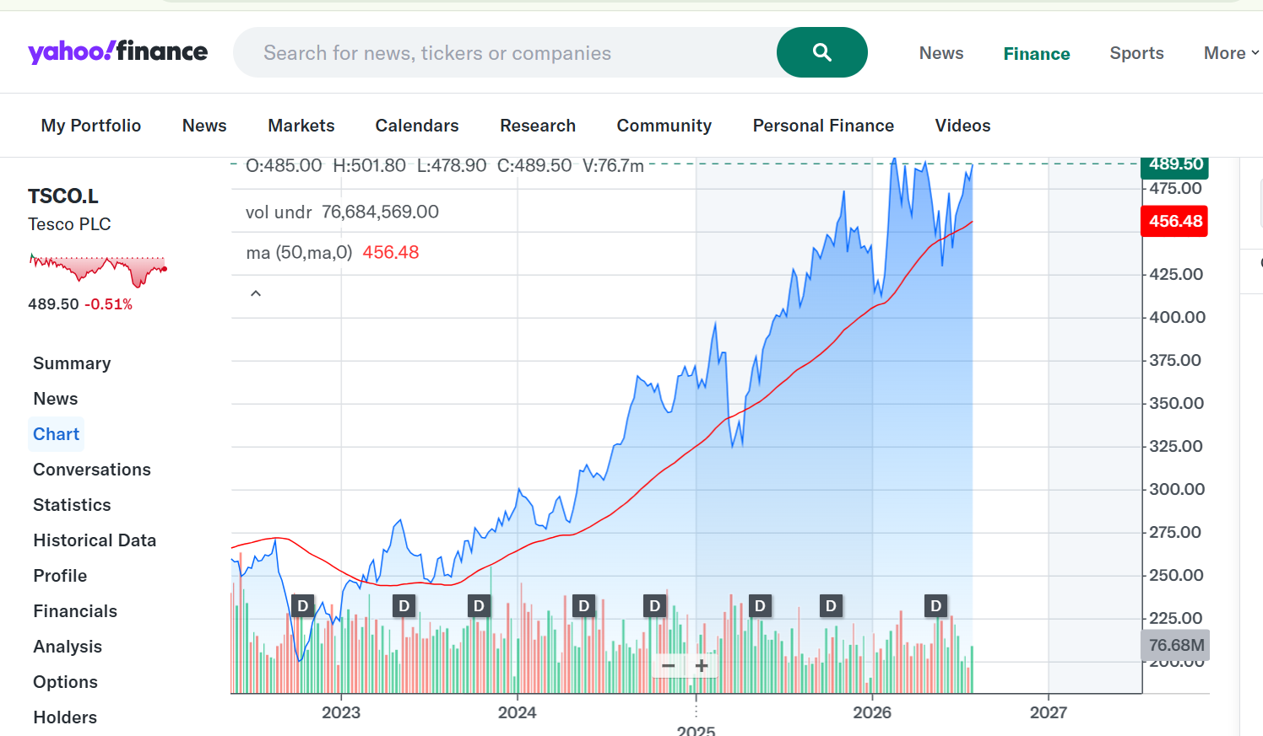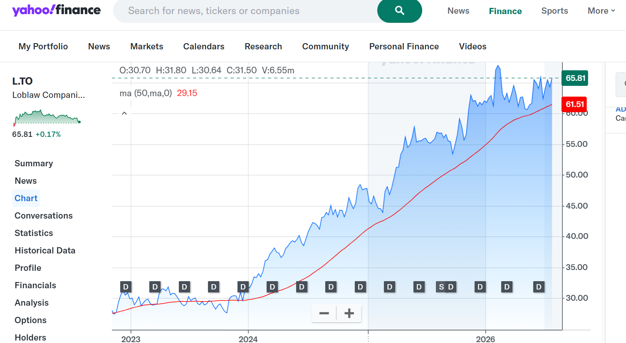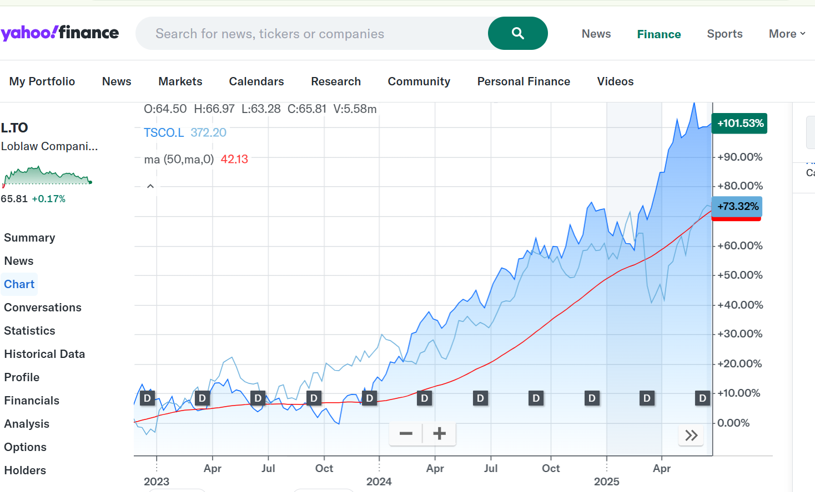
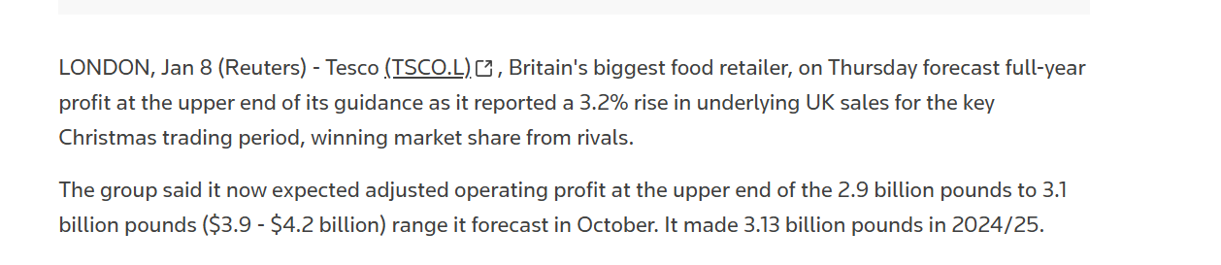
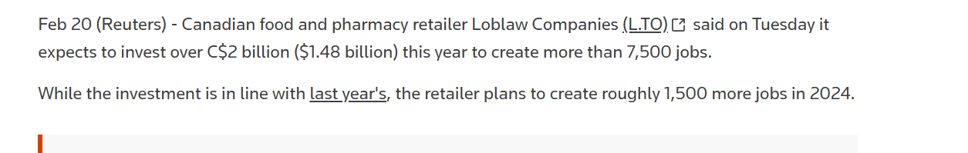
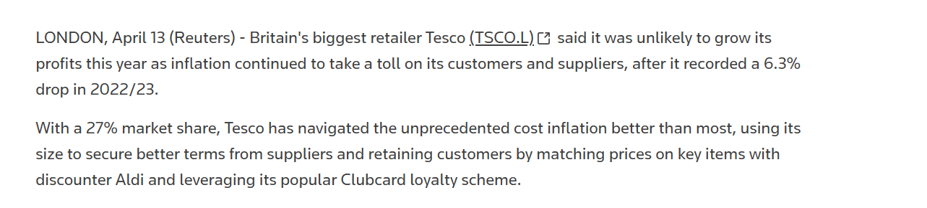

Tesco Claude AI - Calculations/ workings
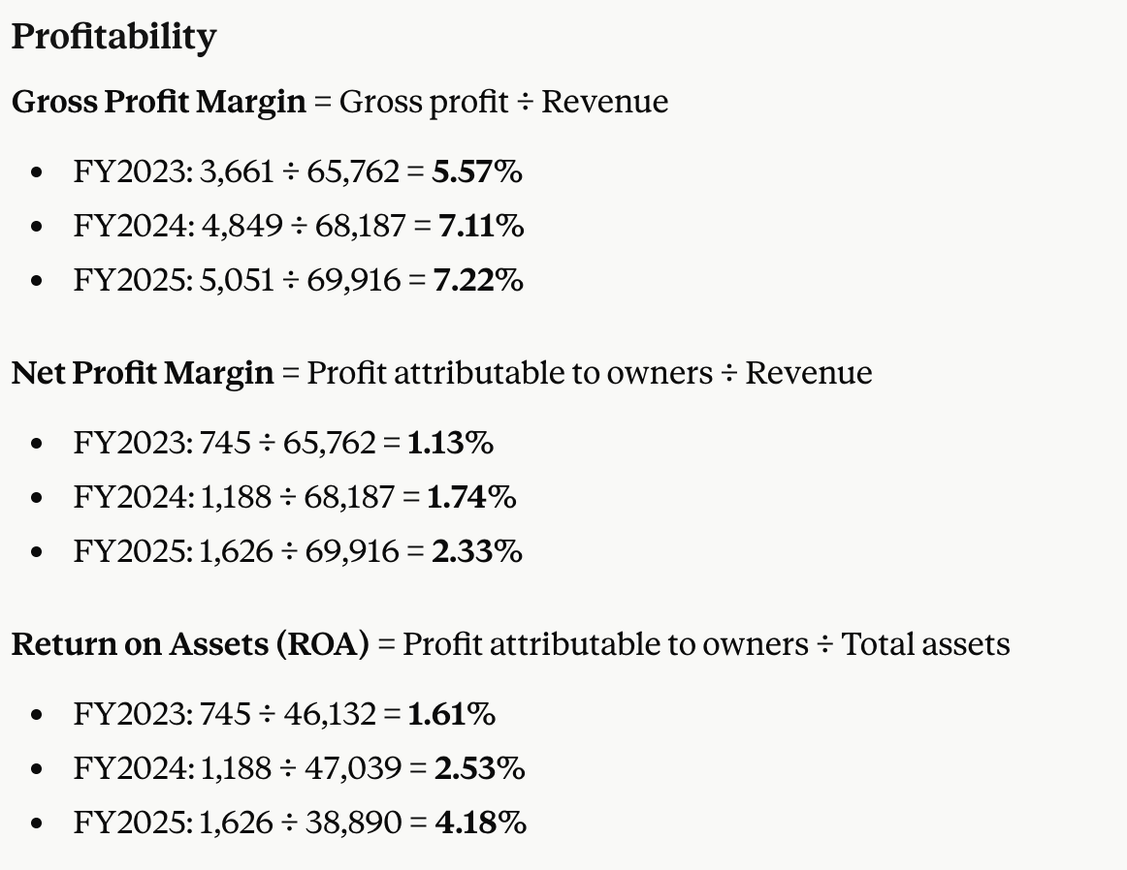
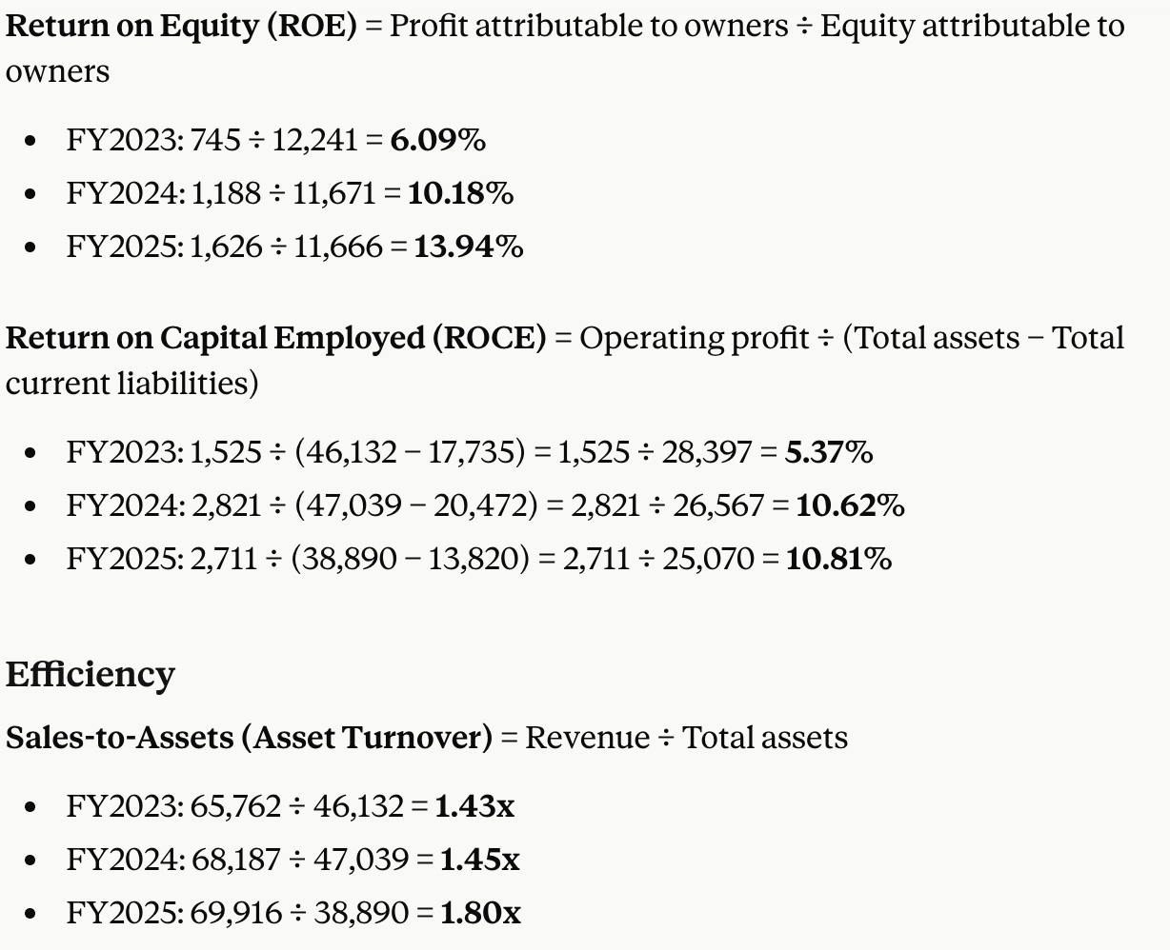
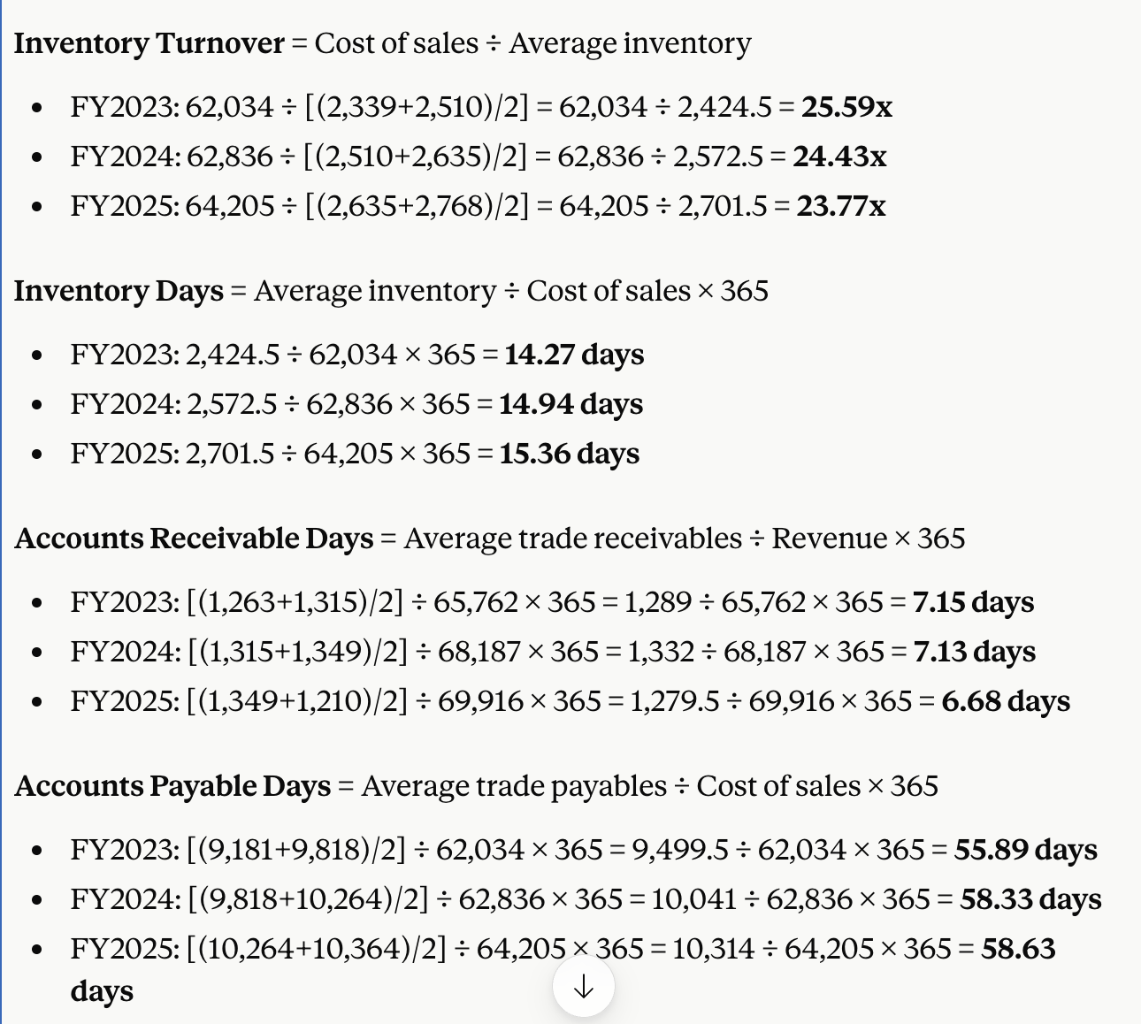

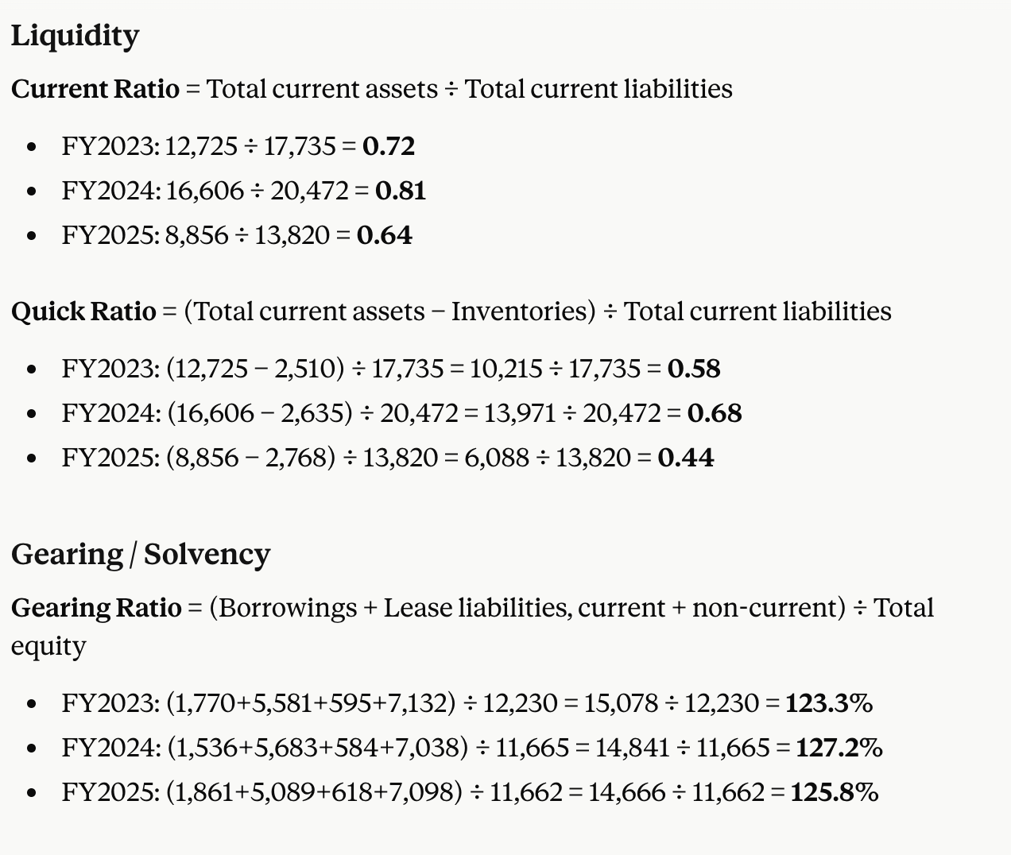

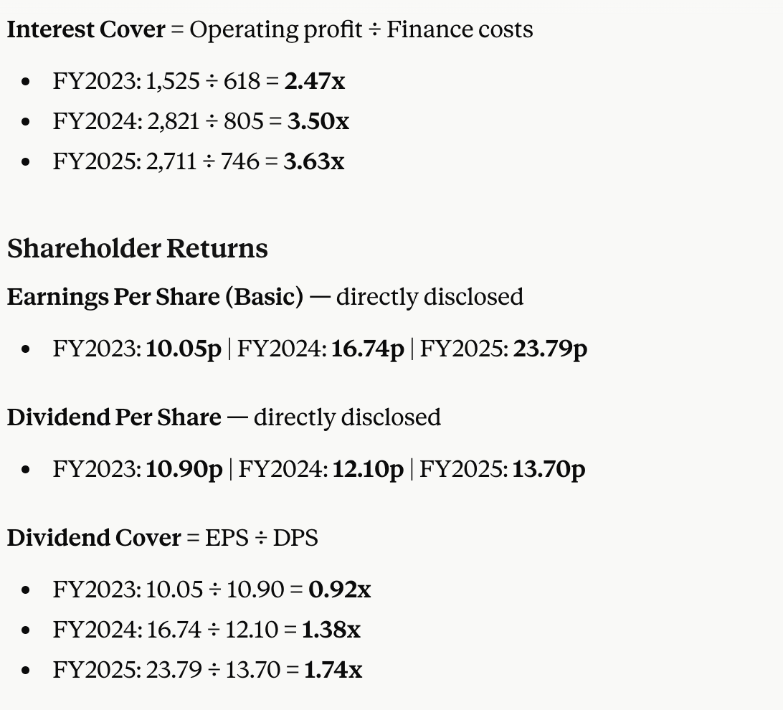

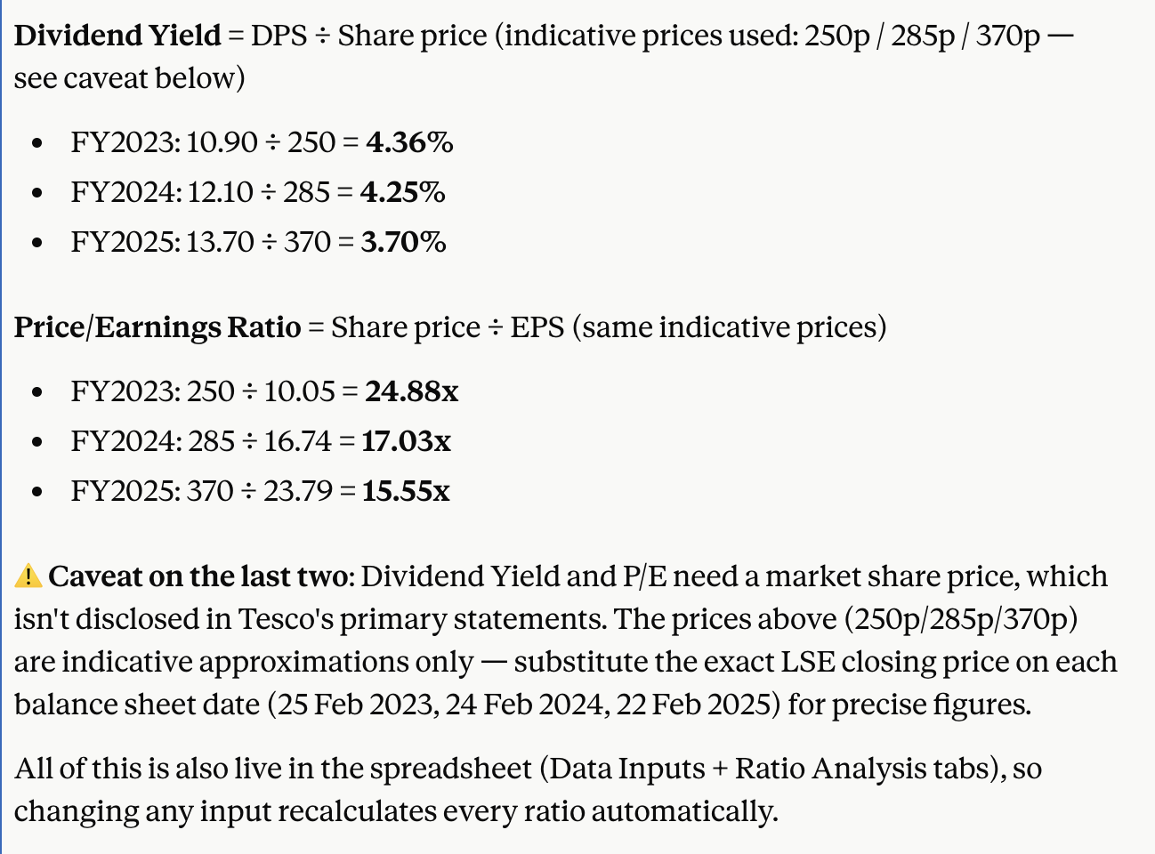

Loblaw Claude AI calculations

